HOMEWORK WEEK 6

# **Introduction:**

*This homework activity introduces you to the creation your Python Programs. To deepen your understanding of Python you are required to attempt all activities and questions presented within this homework.*

# **Activity 1 – Simple Programs**

**Create the flow charts and pseudocode then we will now convert them into Python programs**

1. When the program is run, output a greeting message to the user
2. When the program is run take the name of a user and display a greeting message with their name included.
3. When the program is run take input from the user of a numerical value and use it to calculate the area of a circle.

# **Activity 2 – Challenging Programs**

**These programs will challenge what you have learnt in today’s session. You may wish to pseudocode or flow chart them before programming**

1. Write a program that prints three items, such as the names of your three best friends or favourite movies, on three separate lines.
2. Write a program that prints the sum of the first ten positive integers, 1 + 2 + … + 10.
3. Write a program that prints the product of the first ten positive integers, 1 × 2 × … × 10. (Use * to indicate multiplication in Python.)
4. Write a program that prints a face similar to the following

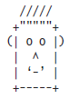

# **Activity 3 – Reflection**

**Provide written responses to the questions below. Answers to these questions can be located in the corresponding topic presentation for this session.**

**Review the following hello.py code:**

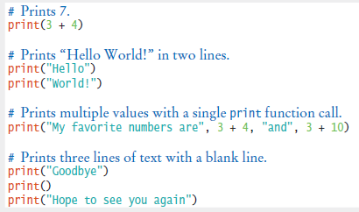

* 1. How do you modify the hello.py program to greet you instead?
  2. How would you modify the hello.py program to print the word “Hello” vertically?
  3. Would the program continue to work if you replaced line 5 of hello.py with:

print(Hello)

* 1. What does the following statement print?

print("My lucky numbers are", 3 * 4 + 5, 5 * 6 – 1)

* 1. What do the following statements print?

print("Hello")

print()

print("World")